Shanghai Journal
1-19-16

Ni Hao,

We just got back from a two-day trip to Suzhou, about 60 miles northwest of Shanghai. Suzhou is called the “Venice of China” and has lots of canals and bridges, as well as classical gardens that have been named UNESCO World Heritage Sites. We took the bullet train from Shanghai Railway Station – only 20 minutes at almost 300 kilometers an hour. We had to go to the train station to get tickets since we decided at the last minute to go. Otherwise, we could have ordered tickets and had them delivered to our residence. It probably was a good thing though, because we went on Saturday to get tickets for Sunday and it took us a good hour to figure out how to navigate the system. The station is enormous (with 18-20 separate waiting rooms for the various trains) and all the signs are in Chinese, of course. We had a hotel reservation with directions in Chinese to show the taxi driver (very important since it is unlikely to find a driver who speaks English or reads English script!)

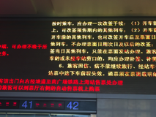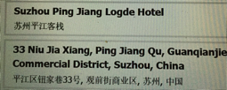

Our trip the next day started out smoothly. We found our train easily and the ride was quick. We had no problem getting a taxi at the station in Suzhou and showed the above script to the driver - so far so good. After a short drive, he pulled over where some construction was blocking the road and told us we would have to walk from there, pointing to a road on our left. We started walking as directed but did not see the hotel. We kept stopping people, showing the above chit and they kept pointing us in the direction we were heading. Finally, a very nice guy who spoke some English put the address in his phone and generously said he would walk with us to the hotel following his GPS. It turned out to be at least a 20-minute walk with a couple of turns but we finally found it. (There are major roads on either end of the street where the hotel is located and we can’t figure out why the driver could not have dropped us at either of those. Especially since the taxi for heading back to the train this morning stopped right in front of the hotel!)

After checking in, we invited Tony for a coffee where we learned he was taking English courses from a place called “Wall Street English” where he met his girlfriend, an instructor there. He was eager to talk to us and spoke English quite well. He is a manager at a business and wanted to know if we knew Ken Blanchard and Situational Leadership Theory. My UMASS friends will know why this is so funny (some of us had a graduate class with Blanchard back in the day).
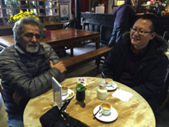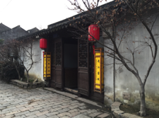

Our first impression of the hotel was very positive. It is converted from an old mansion that was once owned by a family in the Ming Dynasty and is in the center of the old part of town, so it is easy to walk to all the spots nearby. Our room was lovely with a canopy bed, wooden bathtub (in addition to a separate shower) and filled with period pieces (trunks, lamps, vases, pictures, etc.)

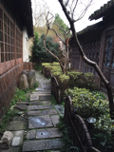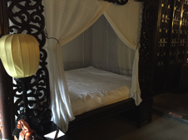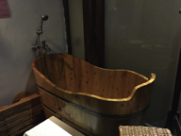

However, it was not a good choice for the very cold and damp couple of days we were there. Though our room had a good heater, it along with the lights turned off whenever we took the key and left the room. Thus, we would have to reheat a large, drafty space – each time we returned. By morning it would be warm enough to take a shower but otherwise we spent a lot of time under the covers.

The area around the hotel was quite lovely. It borders one of the canals and sits along one of the old streets for browsing in shops or sitting to drink tea.
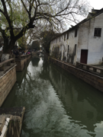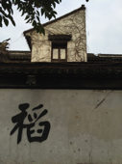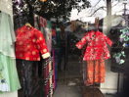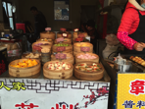
Finding vegetarian food was a challenge. We got a great lead from a young Chinese woman we met at a coffee shop who steered us to a noodle place down a dark alley we probably never would have tried, but turned out to be well worth it. For 40 yuan ($7-8) we had huge bowls of delicious vegetarian noodle soup and a beer.

The next day we walked to the “Humble Administrator’s Garden” – a very elaborate garden built by an imperial envoy and poet of the Ming Dynasty for his retirement, and as you can see – far from humble! We also tried to go the Suzhou Museum, designed by I.M. Pei (whose family is from here) but it was closed on Monday.

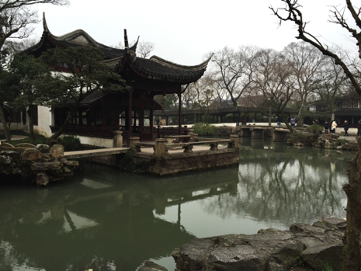

That and several other gardens in Suzhou we will see when we return in April with Kathy and Liz. For now, we are glad to be home in our warm apartment in Shanghai!

Zaijian, Lee

© Lee Anne Bell

